IC-ENC Overlap (Gap) Report
Cell Name RU1A2K00
Overlapping (Adjoining) Coverage
Cell name overlaps with the following existing coverage:
Cell Name Edition: nn(uu)
AU160060 2 (4)

Overlap (Adjoining) Diagram
Sample
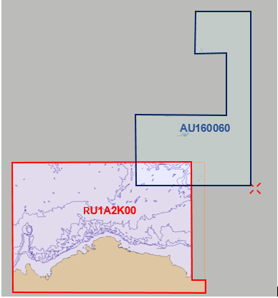
Overlap Consistency
All deep water, and reasonable consistency.

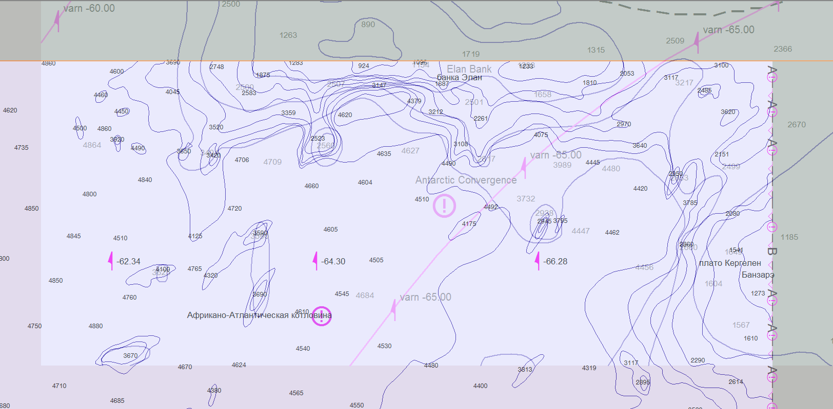

IC-ENC Overlap Summary
ENC 1 | ENC 2 | Data Consistency | Location | Shipping Density | Extent of Overlap | ENC Compilation Scales | Shipping Patterns | Overall
RU1A2K00 | AU160060 | LOW | LOW | N/A | LOW | LOW | MEDIUM | LOW

